**COMPARING THE BEASTS – SYSTEMS - WITH JESUS**

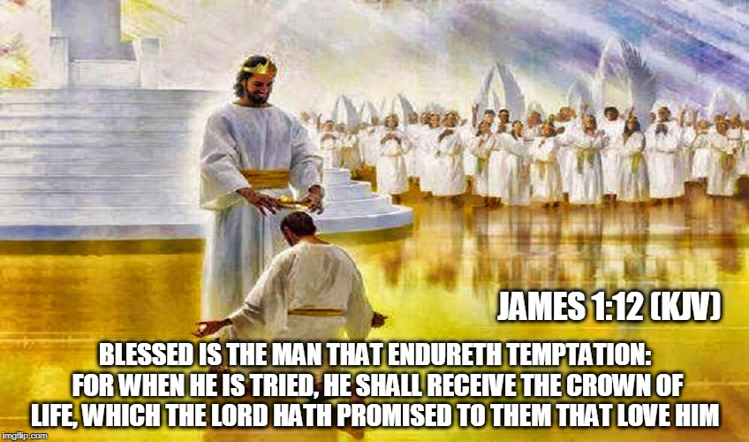

1. **JESUS IS CREATOR** and is therefore worthy of worship but **gives man the power to choose to worship Him** or not.

* **Matthew 15**: **8**This people draweth nigh unto me with their mouth, and honoureth me with their lips; but their heart is far from me. **9**But in vain they do worship me, teaching for doctrines the commandments of men.
* **Revelation 3:20**  Behold, I stand at the door, and knock: if any man hear my voice, and open the door, I will come in to him, and will sup with him, and he with me.
* **John 3:16**  For God so loved the world, that he gave his only begotten Son, that whosoever believeth in him should not perish, but have everlasting life.

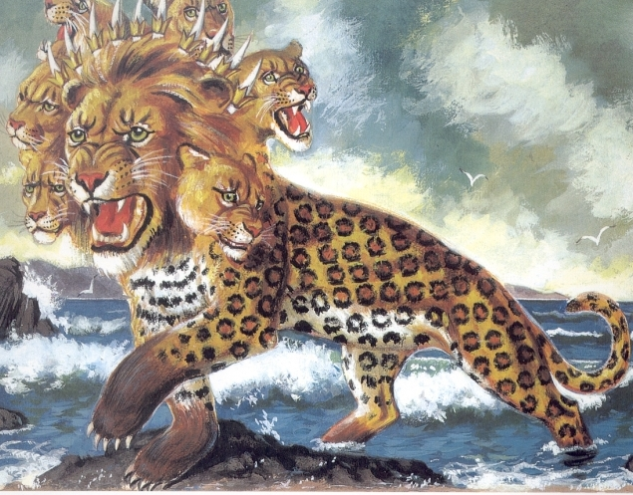

1. THE BEAST SYSTEM **claims to be God** and desires and **forces worship**.

**Revelation 12:17**  And the dragon was wroth with the woman, and went to make war with the remnant of her seed, which keep the commandments of God, and have the testimony of Jesus Christ.

**Revelation 13:15**  And he had power to give life unto the image of the beast, that the image of the beast should both speak, and cause that as many as would not worship the image of the beast should be killed.

**Revelation** 13:16  And he causeth all, both small and great, rich and poor, free and bond, to receive a mark in their right hand, or in their foreheads:

**Revelation** 13:17  And that no man might buy or sell, save he that had the mark, or the name of the beast, or the number of his name.

**EACH INDIVIDUAL MUST CHOOSE FOR OR AGAINST GOD**

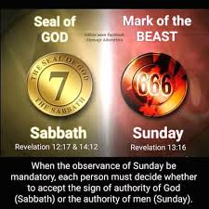

**Romans 14:11** For it is written, *As* I live, saith the Lord, every knee shall bow to me, and every tongue shall confess to God.**Romans 14:12** So then every one of us shall give account of himself to God.

**Philippians 2:12**  Wherefore, my beloved, as ye have always obeyed, not as in my presence only, but now much more in my absence, work out your own salvation with fear and trembling. **Philippians 2:13**  For it is God which worketh in you both to will and to do of *his* good pleasure.

**Joshua 24:15**  And if it seem evil unto you to serve the LORD, choose you this day whom ye will serve; whether the gods which your fathers served that *were* on the other side of the flood, or the gods of the Amorites, in whose land ye dwell: but as for me and my house, we will serve the LORD.

**Deuteronomy 30:19**  I call heaven and earth to record this day against you, *that* I have set before you life and death, blessing and cursing: therefore choose life, that both thou and thy seed may live:

**2 Timothy 2:10** Therefore I endure all things for the elect's sakes, that they may also obtain the salvation which is in Christ Jesus with eternal glory. **2 Timothy 2:11** *It is* a faithful saying: For if we be dead with *him,* we shall also live with *him:* **2** **Timothy** **2:12**If we suffer, we shall also reign with *him:* if we deny *him,* he also will deny us:

**Jas 1:12** Blessed *is* the man that endureth temptation: for when he is tried, he shall receive the crown of life, which the Lord hath promised to them that love him.

**Revelation 2:10**  Fear none of those things which thou shalt suffer: behold, the devil shall cast *some* of you into prison, that ye may be tried; and ye shall have tribulation ten days: be thou faithful unto death, and I will give thee a crown of life.

**Revelation 3:21**  To him that overcometh will I grant to sit with me in my throne, even as I also overcame, and am set down with my Father in his throne.

**Revelation 20:6**  Blessed and holy *is* he that hath part in the first resurrection: on such the second death hath no power, but they shall be priests of God and of Christ, and shall reign with him a thousand years.

**OUR POWER OF CHOICE – HOW WE CHOOSE WILL DETERMINE OUR DESTINY – DETERMINE WHETHER WE ARE SAVED OR LOST**



**MAKE THE RIGHT CHOICE!!**

**2 Timothy 4:8**  Henceforth there is laid up for me a crown of righteousness, which the Lord, the righteous judge, shall give me at that day: and not to me only, but unto all them also that love his appearing.